**TEAM MEETING (month/day/year)**

***Cameron,*** *Diogo, Jose, Samuel, Yujui, Lio*

1 DOF Prototype board with electronics mounted.

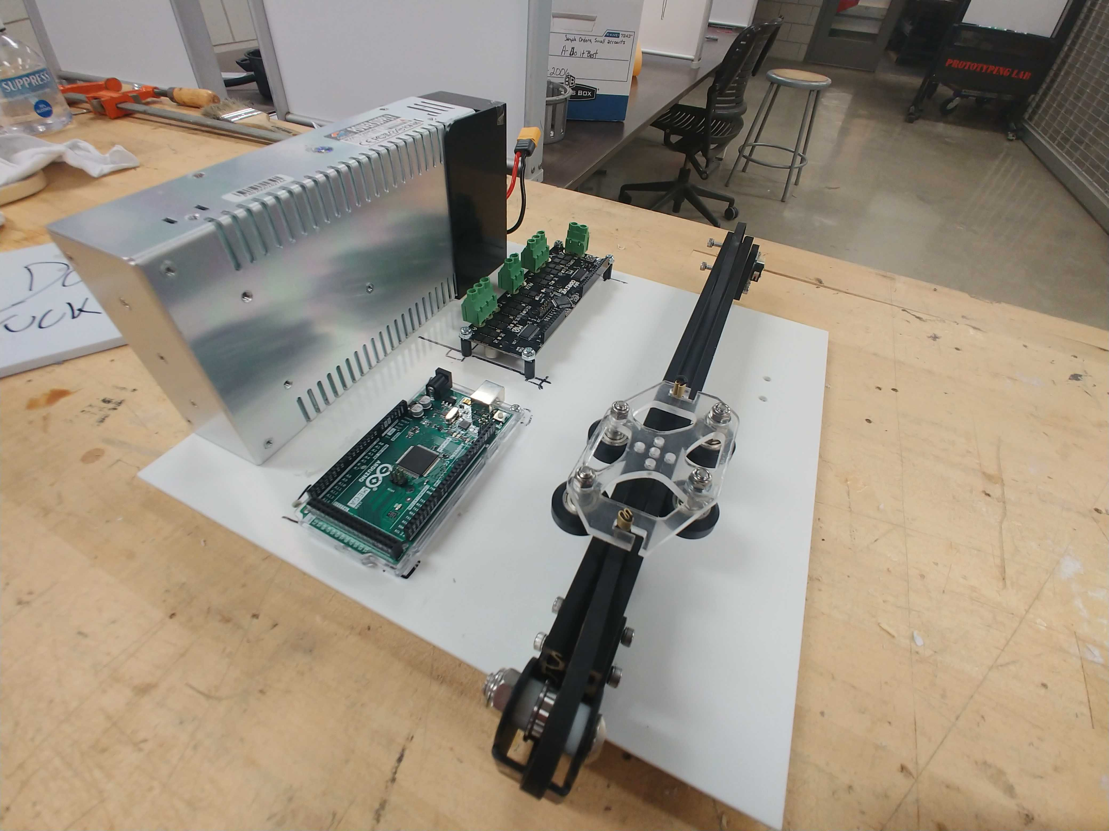

| **No.** | **Agenda and Minutes** | **Actions needed** |
| --- | --- | --- |
| **1/29/22**  **Mech Team Meet** | Mechanism team met to document all of the recent developments and fill out the concepts/sketches assignment. Discussed any further ideas we want to pursue and materials we want to order | Continue constructing prototypes this upcoming week |
| **1/31/2022**  **Whole Class** | Meeting with whole class and teams  Maybe look into CoreXY? Gantry may be possible  Gantry Prototype:   * Consider ordering new 3D printer parts, such as the x-axis, since it was the one that offered the least inertia (as opposed to the z axis)   + Possibly think of what is causing the feeling of the z axis: mass? Friction? * Design Inspiration:   + Axidraw <https://www.axidraw.com/>   + Mechanical Ouiji Board <https://www.youtube.com/watch?v=4B7OTyLYf70> | 1DOF: Cam will make CAD for a 1DOF base, and then laser cut the base and a replacement gantry plate |
| **2/1/2022**  **Team Meeting** | Agenda:   * note: Cam and Jose will be absent Friday * quick progress updates from teams * decide agenda for professor meetings tomorrow * Breakout into subteams   1DOF assembled new top plate and motor onto gantry |  |
| **2/2/2022**  **Meeting w/ Profs** | 1DOF:   * Need Odrive & Encoder from Billy   + Done * do we need fuses/safety stuff?   + No, the ender3 power supply has it * Do we anything in between Power supply and Motor controller? Other than on/off switch obv.   + Nope * Mount everything   + Done   Mechanism   * Develop prototypes for the magnetic components; Consideration given to the inclusion of bearings, air bearings, teflon, nylon balls? * Start looking for screens, especially within the official raspberry components that we could test with. They are generally flat and of unknown thickness. Also keep in mind that thin multi-touch screens can be hard to find * We should go check out the 2R robot - it can roll on a ball without a cantilever * Look up to the mechanism of the phantom - it can use two motors on the ame hub | 1DOF:   * Cam will remake the base to fit all necessary electronics. * Ray will start preparing for connecting to and controlling motor.   Mechanism:   * Sam will work on ideating the cable prototype * Diogo will research about magnet mechanisms and ideate the way the fingers interact with them * Jose will order different magnets for prototyping |

**Meeting notes**

Solving cogging - Build a lookup table

Motor position > cog torque/force

Command opposite of that so motor can compensate when in a cog

Change keep the belt flat to reduce friction

Fix friction, compensate for cogging, power it up

Might need rotary drive if we can't do anything to fix friction

Might be able to easily do admittance control

Can use a cable instead of a belt - can adapt it easily by removing timing pulleys

Mechanism

Official Raspberry pie touch screen!

Generally flat

Unknown thickness

Multi-touch screen are hard to make thin

Touch sensor integrated with display

Phantom uses two motors on the same hub

Fix cable and motor climbs the cable

Play with 2R robot

2R robot can roll on a ball - no cantilever :)

Start with permanent magnets

Nylon ball bearings

Steel ball bearing